MULTILINGUAL STORY GENERATION AND SPEECH SYSTEM
Scope and Limitations
Department of Computer Science and Engineering, TKR College of Engineering & Technology
Batch C2 (CSE-C) · Academic year [ACADEMIC YEAR]
Table 1: Project team
S.No. | Student name | Roll number
1 | Lingala Sindhu | 23K91A05D3
2 | Padige Ajay | 23K91A05H8
3 | Mahek Ansari | 23K91A05D8
4 | Maheshwaram Hari Krishna | 23K91A05D9

Project guide: A Tejaswini
Chapter and section numbers quoted in the text (for example Chapter 8 or Section 6.2) refer to the full project report, 17.Final Document. Figures and tables in this document are numbered from 1.

1. SCOPE
The scope follows the six batch objectives and what could be measured on one laptop. It is stated first as what the product and its measurements cover, then as what they deliberately leave out, so that a reader does not mistake an offline experiment for a product feature.

1.1 In scope
• Input: a free-text story idea of up to 2,000 characters, one of 15 languages (en, hi, es, fr, de, it, pt, ru, ar, tr, nl, pl, zh, ja, ko), one of eight styles and one of three lengths.
• Story generation: the Qwen3-0.6B model through a text-generation pipeline with token budgets of 220, 420 and 700, and the offline composer as a fallback.
• Narration: per-language MMS (VITS) checkpoints at 16 kHz, long text split into chunks of at most 380 characters, an operating-system voice as a fallback; WAV download and in-browser playback.
• Storage and interface: SQLite library of stories, audio records and evaluation runs; Landing, Studio, History, Story detail and Evaluation pages; light and dark themes.
• Evaluation: WER and CER by Whisper-small round trip, multilingual sentence-embedding similarity, ROUGE-L, latency and RTF in the application; language match, instruction echo and distinct-2 in the experiments.
• Product support: the REST API, automated tests, measurement and screenshot scripts.

1.2 Out of scope
• Translation of an existing story from one language to another: there is no translation module.
• Choice of voice, speaker or speed, emotion control, voice cloning and reference-audio upload.
• Reading-level control and age-appropriateness checks of the generated text.
• Training, fine-tuning or quantising any model; GPU optimisation.
• Human rating of stories or narration (the batch objective of user rating).
• Accounts, several users, cloud deployment, authentication, rate limiting and monitoring: StoryVox is a single-user local tool.
The table below sets the scope against the six batch objectives, separating what the product does, what only the measurements cover and what was not done.
Table 2: Scope against the batch objectives
Objective | In the product | Measured offline | Not done
1 Accept a prompt | Studio form, validation, 2,000-character limit | - | Prompt templates, saved prompts
2 Generate with length and reading-level controls | 3 lengths, 8 styles | Length scaling (175, 316, 418 words) | Reading-level control
3 Translate into target languages | Language requested in the prompt | Language match 3/17 (A), 8/17 (B) | A translation module
4 Convert to speech | MMS narration for 12 languages, OS fallback | 150-sentence round trip | Italian, Chinese and Japanese MMS voices
5 Playback with voice, speed, language | Player, download, regenerate | - | Voice and speed selection
6 Evaluate through user rating | Automated evaluation page | Story-length WER/CER with chunking | User rating; working WER/CER on the page

2. ASSUMPTIONS
• The pretrained models are used as published; their quality in the 15 languages is what their authors released, not something this project can change.
• Ten length-filtered FLEURS sentences per language are a fair, if small, sample of read-aloud text for the narration stage.
• A Whisper-small transcript is a reasonable proxy for what a listener would understand; its own errors are included in every WER and CER and were not separated out.
• The story idea "A young inventor discovers a hidden library." and seed 0 represent a typical request; other ideas and seeds would give other texts.
• A language detector is accurate enough on 100 to 200 words to say whether a story is in the requested language; it is used as a coarse screen, not as a measure of quality.
• One user runs the application on one computer, so the model objects, the database and the audio folder need no coordination between users.
• The model weights are downloaded once from the Hugging Face Hub and cached; after that the application needs no network.

3. LIMITATIONS

Models and language
• The story model does not follow the requested language. With the shipped prompt, 3 of 17 stories (the English ones) were in the requested language and 4 of 4 live stories in other languages were English; the chat template raises this only to 8 of 17.
• A small model, a plain prompt. Qwen3-0.6B often echoes its instructions (instruction echo 0.097 in the shipped path against 0.006 with the chat template) and wrote Untitled Story for 15 of 17 shipped-path titles. Stories are short, repetitive and sometimes not stories.
• Three advertised languages are not usable as shown. facebook/mms-tts-ita, -cmn and -jpn do not exist, so Italian is read by an English voice and Chinese and Japanese mostly produce no audio on the test machine.
• Seed and variety. The experiments fixed one seed, which makes many shipped-path stories nearly identical across languages and hides how much a different seed would change the text.

Evaluation
• No human judgement. Coherence, creativity, age-appropriateness and naturalness of the voice were never rated by a person; the proxies (language match, echo, distinct-2, similarity, ROUGE-L) can show failure but not quality.
• Whisper-small is inside every WER and CER. The recogniser is weaker in some languages (Hindi, Arabic), and its error on natural speech was not measured.
• Small samples. 10 sentences per language, 17 stories per condition, 7 live generations; differences of a few hundredths are not reliable.
• The product's own evaluation cannot score a story. The transcription call fails for audio over 30 seconds, so every WER and CER on the Evaluation page is empty for real stories.

Product
• Single user, local only. No login, one shared model object, no rate limit, no queue; the generate route blocks until the story and the narration are finished.
• Dependencies are under-declared. ffmpeg (needed by the recogniser) and uroman (needed for Korean) are missing from the requirements, and the stored virtual environment pointed at an interpreter that does not exist on the test machine.
• Title parsing. Only a bare Title: at the start of a line is recognised, so bold or prefixed titles stay in the title field or the title is Untitled Story.
• Evaluation cost. The similarity function loads a sentence-embedding model on every sample.
• Model loading. The story pipeline is created with trust_remote_code=True; the trusted model name is set by configuration.

Hardware, software and process
• One machine, CPU only. All timings come from one i5-12500 with 15.7 GB of memory while other programs ran; the GPU path exists in the code but was not run.
• Software versions. Results were produced with transformers 5.20.2 and torch 2.14.1 on Python 3.11.9; other versions can change both behaviour and speed (the 30-second recogniser failure is such a case).
• Tests use stand-ins. The 29 automated tests replace the models; the real models are exercised only by the measurement scripts.
• No independent review or security audit of the code was carried out.

How the limits affect the reading of the results
The narration results are the most reliable part of the project, because they rest on a public corpus and a repeatable round trip, and they are limited by sample size and by the recogniser. The story results are indicative: they show clearly that the shipped path ignores the requested language and often fails to produce a story, but they cannot rank stories by quality. The product results describe a local tool for one person, not a service.
Two figures show the limitations that matter most for reading the numbers. The first shows, for every one of the 17 story requests, whether the story came out in the language that was asked for: with the shipped prompt the small story model answers in English almost every time, so a request for another language is not honoured. The second shows the round-trip error of the narration per language, where the hatched bars mark the languages that had no speech model and were read by an operating-system voice.
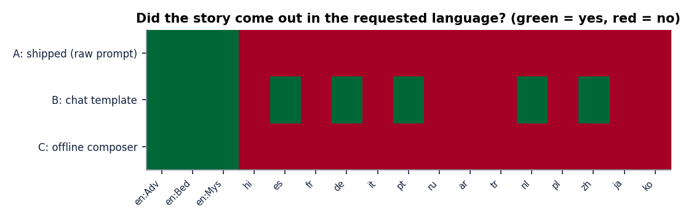
Figure 1: Language match of the generated story for the shipped prompt (A), the chat-template variant (B) and the offline composer (C).
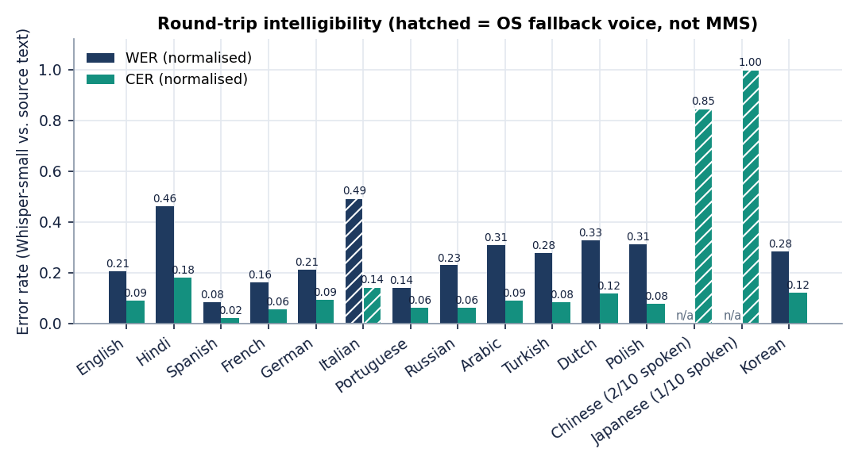
Figure 2: Round-trip WER and CER per language; hatched bars were narrated by an operating-system voice.

4. WHAT WAS NOT MEASURED
The following were not measured, so no document claims anything about them. Each is either outside what the product does or beyond what a CPU laptop and a short project could test.
• Human ratings of story coherence, story quality, voice naturalness or the usefulness of the application to children, teachers or language learners.
• Whisper-small's error on natural recordings of the same sentences, which would separate the recogniser's error from the speech model's.
• GPU speed, and speed or quality of larger models (a bigger Qwen3 model, other speech models).
• Story quality with other ideas, other seeds, other styles than Adventure for the non-English languages, or longer texts in a language other than English.
• Narration with an installed Chinese, Japanese or Italian system voice.
• Concurrent users, long-running load and memory growth of the server.
• Accessibility of the interface with a screen reader, other browsers and phones.
• Security: no penetration test or code audit was done.
None of these is hidden in a headline number. The claims of the abstract about translation, adjustable voice and speed, and user-rated evaluation are therefore treated as aims, not as results.

